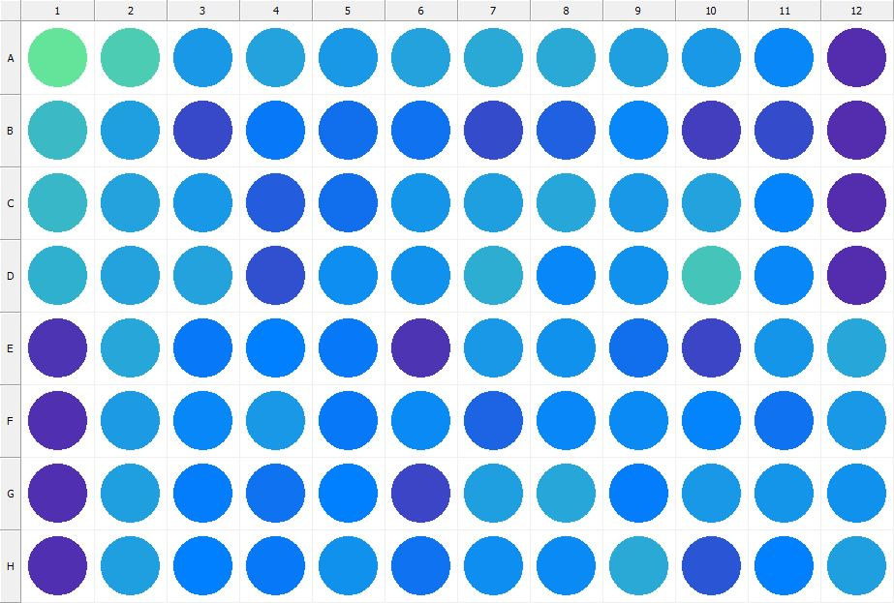

|  |
| --- |
| **Results for Tim_CTB(1) - channel 1 (RFU)** |

|  |  |  |  |  |  |  |  |  |  |  |  |  |
| --- | --- | --- | --- | --- | --- | --- | --- | --- | --- | --- | --- | --- |
|  | 01 | 02 | 03 | 04 | 05 | 06 | 07 | 08 | 09 | 10 | 11 | 12 |
| A | 152656 | 135992 | 102352 | 109829 | 101694 | 109361 | 113522 | 114638 | 106651 | 101213 | 89953 | 30031 |
| B | 124657 | 107318 | 49333 | 81625 | 75069 | 77150 | 52039 | 65791 | 90081 | 42581 | 50638 | 29443 |
| C | 123416 | 110110 | 101160 | 63314 | 75203 | 99913 | 107614 | 112427 | 102251 | 108993 | 89130 | 30563 |
| D | 117664 | 110005 | 108877 | 52973 | 95619 | 97971 | 116130 | 91008 | 97080 | 131505 | 89307 | 30529 |
| E | 35212 | 110745 | 80874 | 84901 | 81911 | 34108 | 102314 | 97475 | 74417 | 45342 | 99707 | 110180 |
| F | 33427 | 104812 | 90626 | 101592 | 82339 | 92094 | 67974 | 89460 | 93713 | 87966 | 75892 | 103170 |
| G | 31554 | 106890 | 82834 | 75781 | 85543 | 47490 | 107407 | 110453 | 84360 | 101892 | 99133 | 96439 |
| H | 31606 | 105988 | 85259 | 80653 | 96693 | 76813 | 95244 | 93375 | 112736 | 57949 | 85979 | 107224 |

|  |  |
| --- | --- |
| **Plate information** | |
|  | |
| **Plate** | 1 |
| **Repeat** | 1 |
| **Barcode** |  |
| **Measured height** | 14.78 |
| **Inside temperature at start** | 23.54 |
| **Inside temperature at end** | 23.56 |
| **Humidity at start** | 14.1 |
| **Humidity at end** | 14.9 |
| **Ambient temperature at start** | 24.03 |
| **Ambient temperature at end** | 24.14 |
| **Group** | 1 |
| **Label** | Tim_CTB(1) |
| **ScanX** | 0 |
| **ScanY** | 0 |
| **Measinfo** | De=1st Ex=Top Em=Top Wdw=N/A (14) |
| **Kinetics** | 0 |
| **Measurement date** | 11/21/2022 12:14:29 PM |
|  | |

|  |
| --- |
| **Background information** |
| Legend:  HDR1 - Plate  HDR2 - Label  HDR3 - Result  HDR4 - Signal  HDR5 - Flashes/Time  HDR6 - Meastime  HDR7 - MeasInfo |
| HDR1 HDR2 HDR3 HDR4 HDR5 HDR6 HDR7  1 Tim_CTB 0 1113 1 00:00:00.000 De=1st Ex=Top Em=Top Wdw=N/A (14) |
|  |

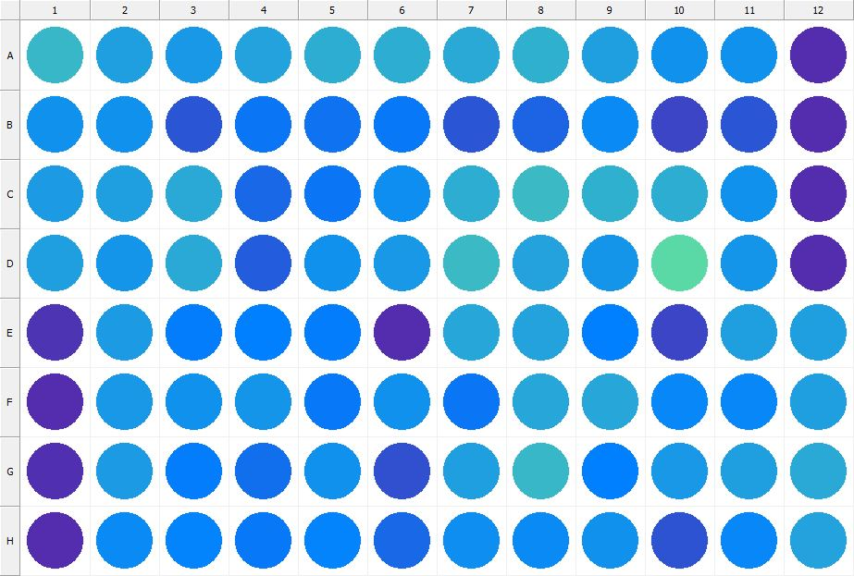

|  |
| --- |
| **Results for Tim_CTB(1) - channel 1 (RFU)** |

|  |  |  |  |  |  |  |  |  |  |  |  |  |
| --- | --- | --- | --- | --- | --- | --- | --- | --- | --- | --- | --- | --- |
|  | 01 | 02 | 03 | 04 | 05 | 06 | 07 | 08 | 09 | 10 | 11 | 12 |
| A | 123664 | 106471 | 101851 | 107967 | 117085 | 116387 | 113706 | 118979 | 106669 | 98255 | 96507 | 31073 |
| B | 97558 | 98121 | 57916 | 78570 | 76665 | 81329 | 57023 | 66719 | 92821 | 45686 | 57953 | 30048 |
| C | 105157 | 106326 | 114126 | 69547 | 79577 | 95304 | 115626 | 126389 | 118951 | 115392 | 96424 | 30529 |
| D | 105903 | 99479 | 113385 | 62312 | 97874 | 102874 | 125946 | 110007 | 99971 | 146393 | 99958 | 30343 |
| E | 34626 | 103767 | 82564 | 86119 | 83917 | 29476 | 111161 | 108292 | 85689 | 47538 | 107557 | 107383 |
| F | 30725 | 101856 | 97836 | 100400 | 81571 | 97243 | 78384 | 110573 | 111185 | 89512 | 89360 | 105680 |
| G | 31717 | 103964 | 84502 | 74411 | 97188 | 53302 | 107107 | 122951 | 85161 | 102267 | 106882 | 113080 |
| H | 29305 | 92344 | 88254 | 80415 | 88249 | 69570 | 94470 | 92155 | 97379 | 55662 | 90757 | 109497 |

|  |  |
| --- | --- |
| **Plate information** | |
|  | |
| **Plate** | 2 |
| **Repeat** | 1 |
| **Barcode** |  |
| **Measured height** | 14.78 |
| **Inside temperature at start** | 23.54 |
| **Inside temperature at end** | 23.56 |
| **Humidity at start** | 14.3 |
| **Humidity at end** | 14.6 |
| **Ambient temperature at start** | 24.22 |
| **Ambient temperature at end** | 24.24 |
| **Group** | 1 |
| **Label** | Tim_CTB(1) |
| **ScanX** | 0 |
| **ScanY** | 0 |
| **Measinfo** | De=1st Ex=Top Em=Top Wdw=N/A (14) |
| **Kinetics** | 0 |
| **Measurement date** | 11/21/2022 12:15:15 PM |
|  | |

|  |
| --- |
| **Background information** |
| Legend:  HDR1 - Plate  HDR2 - Label  HDR3 - Result  HDR4 - Signal  HDR5 - Flashes/Time  HDR6 - Meastime  HDR7 - MeasInfo |
| HDR1 HDR2 HDR3 HDR4 HDR5 HDR6 HDR7  2 Tim_CTB 0 1150 1 00:00:00.000 De=1st Ex=Top Em=Top Wdw=N/A (14) |
|  |

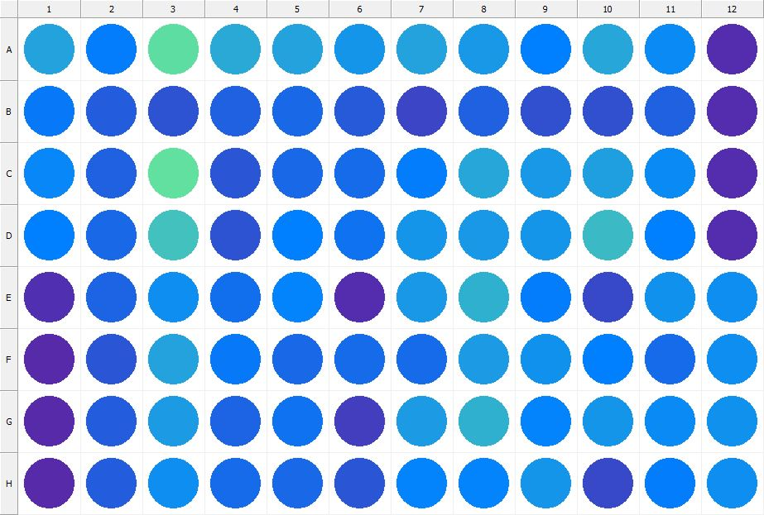

|  |
| --- |
| **Results for Tim_CTB(1) - channel 1 (RFU)** |

|  |  |  |  |  |  |  |  |  |  |  |  |  |
| --- | --- | --- | --- | --- | --- | --- | --- | --- | --- | --- | --- | --- |
|  | 01 | 02 | 03 | 04 | 05 | 06 | 07 | 08 | 09 | 10 | 11 | 12 |
| A | 110048 | 82869 | 149038 | 113434 | 109520 | 99612 | 109810 | 102919 | 86194 | 111675 | 93532 | 29699 |
| B | 81610 | 63026 | 54569 | 65752 | 70214 | 60346 | 47011 | 64180 | 52318 | 53070 | 63918 | 29403 |
| C | 90918 | 65267 | 149872 | 58934 | 69666 | 72993 | 84021 | 111248 | 101919 | 106421 | 93063 | 29447 |
| D | 85073 | 68903 | 130532 | 54617 | 84858 | 75532 | 100793 | 101160 | 100212 | 125541 | 85831 | 29630 |
| E | 31948 | 67148 | 93964 | 74668 | 87828 | 30583 | 102853 | 118390 | 83732 | 48321 | 98502 | 94578 |
| F | 28857 | 59086 | 109937 | 81747 | 69210 | 71941 | 71804 | 104248 | 98334 | 85957 | 72309 | 94547 |
| G | 28791 | 61505 | 104824 | 67404 | 76475 | 41596 | 104423 | 117532 | 87340 | 99238 | 93912 | 97997 |
| H | 28302 | 62592 | 95413 | 71810 | 68845 | 57213 | 87809 | 87472 | 98986 | 49046 | 83286 | 94706 |

|  |  |
| --- | --- |
| **Plate information** | |
|  | |
| **Plate** | 3 |
| **Repeat** | 1 |
| **Barcode** |  |
| **Measured height** | 14.78 |
| **Inside temperature at start** | 23.64 |
| **Inside temperature at end** | 23.66 |
| **Humidity at start** | 14.3 |
| **Humidity at end** | 14.3 |
| **Ambient temperature at start** | 24.32 |
| **Ambient temperature at end** | 24.34 |
| **Group** | 1 |
| **Label** | Tim_CTB(1) |
| **ScanX** | 0 |
| **ScanY** | 0 |
| **Measinfo** | De=1st Ex=Top Em=Top Wdw=N/A (14) |
| **Kinetics** | 0 |
| **Measurement date** | 11/21/2022 12:16:25 PM |
|  | |

|  |
| --- |
| **Background information** |
| Legend:  HDR1 - Plate  HDR2 - Label  HDR3 - Result  HDR4 - Signal  HDR5 - Flashes/Time  HDR6 - Meastime  HDR7 - MeasInfo |
| HDR1 HDR2 HDR3 HDR4 HDR5 HDR6 HDR7  3 Tim_CTB 0 1167 1 00:00:00.000 De=1st Ex=Top Em=Top Wdw=N/A (14) |
|  |

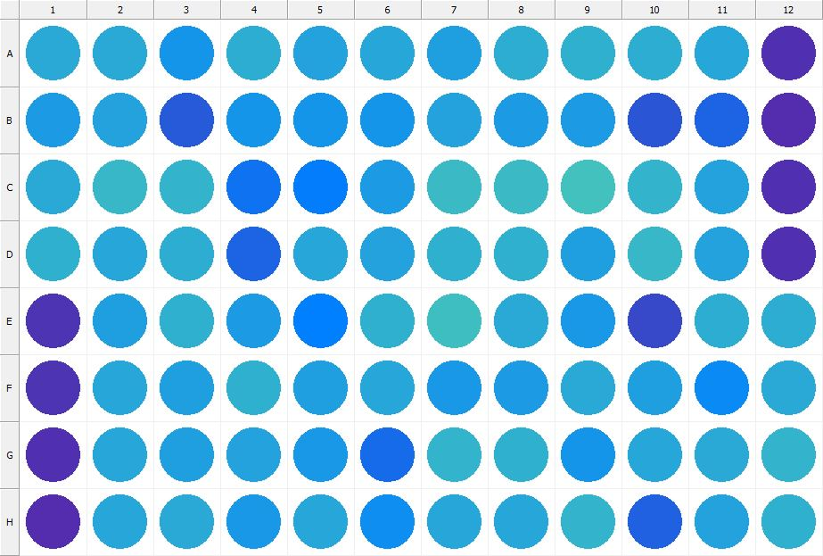

|  |
| --- |
| **Results for Tim_CTB(1) - channel 1 (RFU)** |

|  |  |  |  |  |  |  |  |  |  |  |  |  |
| --- | --- | --- | --- | --- | --- | --- | --- | --- | --- | --- | --- | --- |
|  | 01 | 02 | 03 | 04 | 05 | 06 | 07 | 08 | 09 | 10 | 11 | 12 |
| A | 113699 | 112636 | 99008 | 116954 | 108940 | 111963 | 106600 | 115509 | 118601 | 116655 | 111017 | 31861 |
| B | 103621 | 109799 | 61329 | 99573 | 100856 | 100644 | 109333 | 104299 | 104775 | 57751 | 67373 | 30489 |
| C | 114602 | 122685 | 119764 | 77280 | 84547 | 105348 | 125214 | 126207 | 131007 | 119983 | 109028 | 31442 |
| D | 118482 | 111224 | 115390 | 67971 | 111567 | 108789 | 118229 | 118469 | 107142 | 123503 | 107887 | 31411 |
| E | 35011 | 107693 | 117382 | 103243 | 85748 | 117701 | 126517 | 113298 | 100928 | 49302 | 116567 | 115026 |
| F | 34421 | 111695 | 106768 | 118058 | 106945 | 112040 | 102790 | 103236 | 113277 | 107024 | 93328 | 114535 |
| G | 32422 | 111272 | 107831 | 108657 | 103148 | 72542 | 119908 | 118821 | 98937 | 112353 | 113022 | 120482 |
| H | 29977 | 110543 | 112500 | 101963 | 112337 | 94948 | 111435 | 111495 | 119502 | 64836 | 109283 | 118663 |

|  |  |
| --- | --- |
| **Plate information** | |
|  | |
| **Plate** | 4 |
| **Repeat** | 1 |
| **Barcode** |  |
| **Measured height** | 14.78 |
| **Inside temperature at start** | 23.64 |
| **Inside temperature at end** | 23.64 |
| **Humidity at start** | 14.3 |
| **Humidity at end** | 14.3 |
| **Ambient temperature at start** | 24.32 |
| **Ambient temperature at end** | 24.32 |
| **Group** | 1 |
| **Label** | Tim_CTB(1) |
| **ScanX** | 0 |
| **ScanY** | 0 |
| **Measinfo** | De=1st Ex=Top Em=Top Wdw=N/A (14) |
| **Kinetics** | 0 |
| **Measurement date** | 11/21/2022 12:17:14 PM |
|  | |

|  |
| --- |
| **Background information** |
| Legend:  HDR1 - Plate  HDR2 - Label  HDR3 - Result  HDR4 - Signal  HDR5 - Flashes/Time  HDR6 - Meastime  HDR7 - MeasInfo |
| HDR1 HDR2 HDR3 HDR4 HDR5 HDR6 HDR7  4 Tim_CTB 0 1056 1 00:00:00.000 De=1st Ex=Top Em=Top Wdw=N/A (14) |
|  |

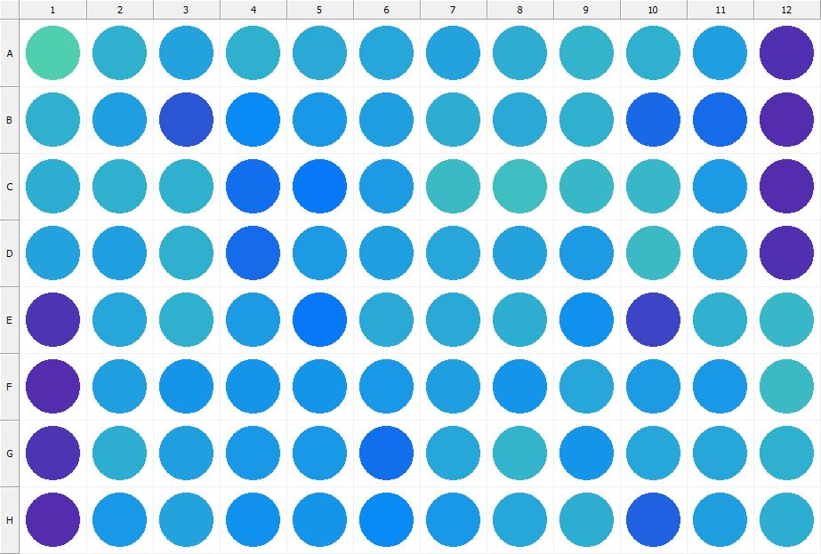

|  |
| --- |
| **Results for Tim_CTB(1) - channel 1 (RFU)** |

|  |  |  |  |  |  |  |  |  |  |  |  |  |
| --- | --- | --- | --- | --- | --- | --- | --- | --- | --- | --- | --- | --- |
|  | 01 | 02 | 03 | 04 | 05 | 06 | 07 | 08 | 09 | 10 | 11 | 12 |
| A | 138091 | 118478 | 108639 | 117761 | 114400 | 111369 | 108333 | 115499 | 121539 | 118580 | 105904 | 31687 |
| B | 117317 | 106153 | 57549 | 93100 | 102571 | 107220 | 116787 | 113984 | 118869 | 68987 | 72876 | 30082 |
| C | 116188 | 118373 | 118279 | 74057 | 82138 | 104677 | 124717 | 126731 | 123059 | 122285 | 105269 | 31060 |
| D | 109437 | 106941 | 117589 | 72870 | 105381 | 105791 | 111660 | 108868 | 104436 | 126330 | 111313 | 32076 |
| E | 34024 | 112006 | 117757 | 105385 | 81863 | 114568 | 113104 | 117020 | 98163 | 47409 | 118904 | 122438 |
| F | 30671 | 106144 | 100772 | 99513 | 99436 | 102458 | 106200 | 99555 | 112014 | 103819 | 102753 | 124508 |
| G | 33841 | 115329 | 106341 | 102580 | 100945 | 73322 | 112017 | 119506 | 100587 | 112106 | 111348 | 118109 |
| H | 29338 | 101219 | 108506 | 96571 | 99950 | 92417 | 102703 | 112460 | 116312 | 64915 | 106381 | 116790 |

|  |  |
| --- | --- |
| **Plate information** | |
|  | |
| **Plate** | 5 |
| **Repeat** | 1 |
| **Barcode** |  |
| **Measured height** | 14.78 |
| **Inside temperature at start** | 23.64 |
| **Inside temperature at end** | 23.64 |
| **Humidity at start** | 14.3 |
| **Humidity at end** | 14.3 |
| **Ambient temperature at start** | 24.32 |
| **Ambient temperature at end** | 24.32 |
| **Group** | 1 |
| **Label** | Tim_CTB(1) |
| **ScanX** | 0 |
| **ScanY** | 0 |
| **Measinfo** | De=1st Ex=Top Em=Top Wdw=N/A (14) |
| **Kinetics** | 0 |
| **Measurement date** | 11/21/2022 12:18:00 PM |
|  | |

|  |
| --- |
| **Background information** |
| Legend:  HDR1 - Plate  HDR2 - Label  HDR3 - Result  HDR4 - Signal  HDR5 - Flashes/Time  HDR6 - Meastime  HDR7 - MeasInfo |
| HDR1 HDR2 HDR3 HDR4 HDR5 HDR6 HDR7  5 Tim_CTB 0 1037 1 00:00:00.000 De=1st Ex=Top Em=Top Wdw=N/A (14) |
|  |

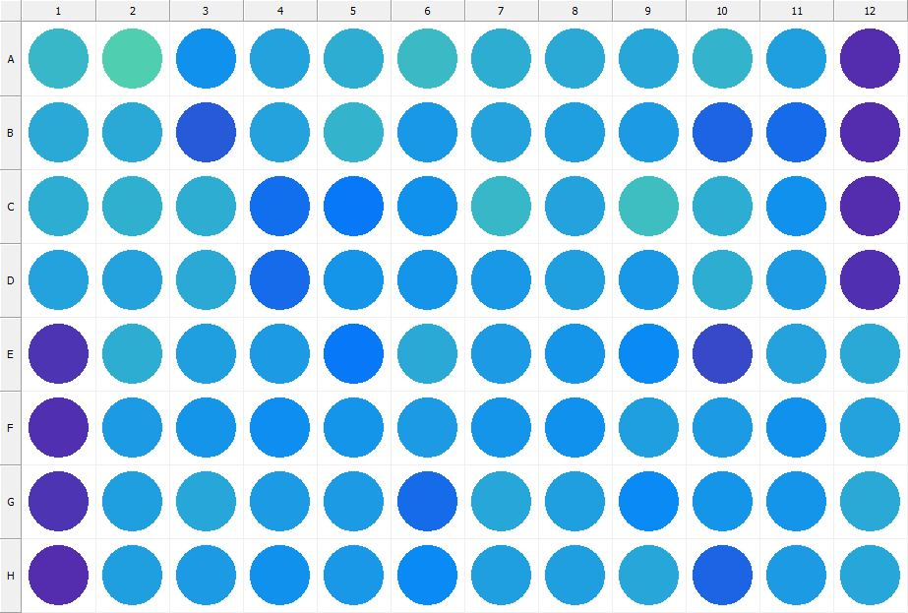

|  |
| --- |
| **Results for Tim_CTB(1) - channel 1 (RFU)** |

|  |  |  |  |  |  |  |  |  |  |  |  |  |
| --- | --- | --- | --- | --- | --- | --- | --- | --- | --- | --- | --- | --- |
|  | 01 | 02 | 03 | 04 | 05 | 06 | 07 | 08 | 09 | 10 | 11 | 12 |
| A | 123981 | 139041 | 97071 | 108295 | 115640 | 124477 | 115711 | 113067 | 112181 | 119814 | 106708 | 31313 |
| B | 113934 | 114077 | 60994 | 108278 | 120303 | 101083 | 109615 | 105675 | 104874 | 66562 | 72125 | 30562 |
| C | 116788 | 117568 | 115269 | 75148 | 81810 | 96552 | 122486 | 110147 | 126986 | 116346 | 98386 | 30812 |
| D | 109552 | 110147 | 112924 | 72495 | 99905 | 98928 | 103085 | 106295 | 101790 | 115966 | 104099 | 31663 |
| E | 34378 | 115181 | 106923 | 104142 | 81956 | 114579 | 103992 | 99415 | 93420 | 49277 | 108718 | 113951 |
| F | 31643 | 105060 | 100460 | 94400 | 99022 | 104266 | 99585 | 97853 | 106345 | 103718 | 96863 | 109160 |
| G | 35571 | 107068 | 110584 | 104484 | 104112 | 72800 | 111754 | 107240 | 92550 | 99148 | 99680 | 112539 |
| H | 30262 | 106259 | 104383 | 97470 | 101076 | 93362 | 106512 | 106420 | 110700 | 66370 | 105514 | 111798 |

|  |  |
| --- | --- |
| **Plate information** | |
|  | |
| **Plate** | 6 |
| **Repeat** | 1 |
| **Barcode** |  |
| **Measured height** | 14.78 |
| **Inside temperature at start** | 23.64 |
| **Inside temperature at end** | 23.66 |
| **Humidity at start** | 14.4 |
| **Humidity at end** | 14.3 |
| **Ambient temperature at start** | 24.22 |
| **Ambient temperature at end** | 24.24 |
| **Group** | 1 |
| **Label** | Tim_CTB(1) |
| **ScanX** | 0 |
| **ScanY** | 0 |
| **Measinfo** | De=1st Ex=Top Em=Top Wdw=N/A (14) |
| **Kinetics** | 0 |
| **Measurement date** | 11/21/2022 12:18:42 PM |
|  | |

|  |
| --- |
| **Background information** |
| Legend:  HDR1 - Plate  HDR2 - Label  HDR3 - Result  HDR4 - Signal  HDR5 - Flashes/Time  HDR6 - Meastime  HDR7 - MeasInfo |
| HDR1 HDR2 HDR3 HDR4 HDR5 HDR6 HDR7  6 Tim_CTB 0 1154 1 00:00:00.000 De=1st Ex=Top Em=Top Wdw=N/A (14) |
|  |

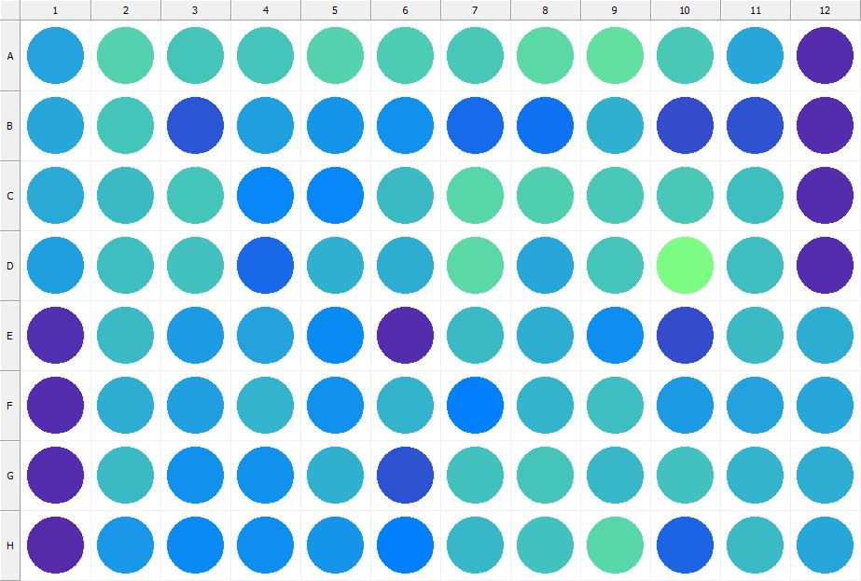

|  |
| --- |
| **Results for Tim_CTB(1) - channel 1 (RFU)** |

|  |  |  |  |  |  |  |  |  |  |  |  |  |
| --- | --- | --- | --- | --- | --- | --- | --- | --- | --- | --- | --- | --- |
|  | 01 | 02 | 03 | 04 | 05 | 06 | 07 | 08 | 09 | 10 | 11 | 12 |
| A | 108106 | 141489 | 131192 | 131468 | 141342 | 137554 | 135660 | 145293 | 149665 | 134834 | 111936 | 30327 |
| B | 110774 | 132826 | 57358 | 105849 | 100048 | 96666 | 71676 | 76305 | 118228 | 51460 | 55461 | 29908 |
| C | 114811 | 124882 | 132538 | 90870 | 90096 | 124648 | 142846 | 138791 | 134188 | 134781 | 127077 | 30181 |
| D | 107692 | 127748 | 130338 | 69574 | 117873 | 116266 | 145292 | 110634 | 133061 | 170214 | 126970 | 30877 |
| E | 32590 | 126383 | 104856 | 110141 | 92989 | 30045 | 125057 | 115227 | 94679 | 51188 | 125146 | 117114 |
| F | 29120 | 116994 | 106796 | 120408 | 96934 | 119948 | 86472 | 121591 | 128482 | 104960 | 109098 | 110974 |
| G | 29454 | 124518 | 98544 | 97467 | 118957 | 56646 | 130006 | 132777 | 121999 | 129943 | 119486 | 116177 |
| H | 28177 | 102851 | 93926 | 95858 | 99841 | 85185 | 122842 | 130798 | 143167 | 66792 | 124794 | 112034 |

|  |  |
| --- | --- |
| **Plate information** | |
|  | |
| **Plate** | 7 |
| **Repeat** | 1 |
| **Barcode** |  |
| **Measured height** | 14.78 |
| **Inside temperature at start** | 23.64 |
| **Inside temperature at end** | 23.75 |
| **Humidity at start** | 14.3 |
| **Humidity at end** | 14.3 |
| **Ambient temperature at start** | 24.12 |
| **Ambient temperature at end** | 24.14 |
| **Group** | 1 |
| **Label** | Tim_CTB(1) |
| **ScanX** | 0 |
| **ScanY** | 0 |
| **Measinfo** | De=1st Ex=Top Em=Top Wdw=N/A (14) |
| **Kinetics** | 0 |
| **Measurement date** | 11/21/2022 12:19:25 PM |
|  | |

|  |
| --- |
| **Background information** |
| Legend:  HDR1 - Plate  HDR2 - Label  HDR3 - Result  HDR4 - Signal  HDR5 - Flashes/Time  HDR6 - Meastime  HDR7 - MeasInfo |
| HDR1 HDR2 HDR3 HDR4 HDR5 HDR6 HDR7  7 Tim_CTB 0 1085 1 00:00:00.000 De=1st Ex=Top Em=Top Wdw=N/A (14) |
|  |

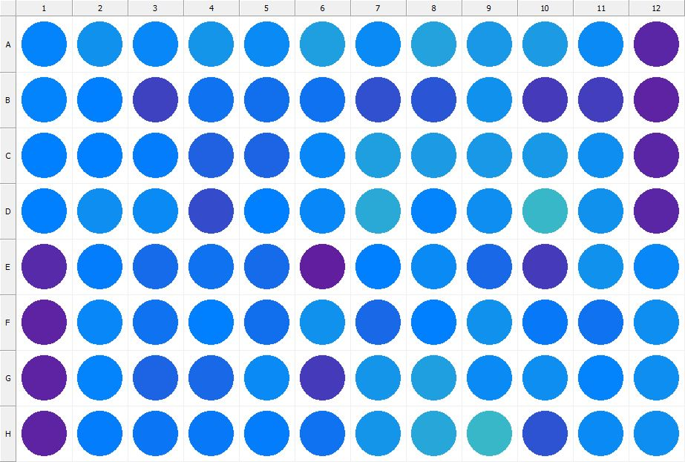

|  |
| --- |
| **Results for Tim_CTB(1) - channel 1 (RFU)** |

|  |  |  |  |  |  |  |  |  |  |  |  |  |
| --- | --- | --- | --- | --- | --- | --- | --- | --- | --- | --- | --- | --- |
|  | 01 | 02 | 03 | 04 | 05 | 06 | 07 | 08 | 09 | 10 | 11 | 12 |
| A | 87249 | 98085 | 90093 | 99613 | 92619 | 107491 | 92750 | 108326 | 101635 | 103225 | 93348 | 25354 |
| B | 87175 | 85161 | 43315 | 77696 | 74397 | 76980 | 54153 | 58520 | 98398 | 40181 | 42450 | 23735 |
| C | 84798 | 84995 | 84662 | 64943 | 67749 | 89776 | 106665 | 104749 | 102092 | 102003 | 95122 | 24439 |
| D | 85915 | 95427 | 92174 | 52127 | 86356 | 90566 | 112816 | 88240 | 94065 | 121932 | 98371 | 24700 |
| E | 26678 | 84418 | 71058 | 76389 | 72905 | 21600 | 86017 | 92513 | 70337 | 39795 | 97870 | 90055 |
| F | 23415 | 91008 | 77488 | 86428 | 75138 | 97889 | 69218 | 85790 | 98545 | 80243 | 75840 | 95000 |
| G | 24178 | 87807 | 66263 | 69240 | 92350 | 40484 | 100028 | 106773 | 92876 | 95410 | 88443 | 94580 |
| H | 23995 | 83653 | 79557 | 81709 | 83542 | 76574 | 99160 | 110865 | 123502 | 56052 | 93559 | 95347 |

|  |  |
| --- | --- |
| **Plate information** | |
|  | |
| **Plate** | 8 |
| **Repeat** | 1 |
| **Barcode** |  |
| **Measured height** | 16.18 |
| **Inside temperature at start** | 23.73 |
| **Inside temperature at end** | 23.75 |
| **Humidity at start** | 14.3 |
| **Humidity at end** | 14.4 |
| **Ambient temperature at start** | 24.03 |
| **Ambient temperature at end** | 24.05 |
| **Group** | 1 |
| **Label** | Tim_CTB(1) |
| **ScanX** | 0 |
| **ScanY** | 0 |
| **Measinfo** | De=1st Ex=Top Em=Top Wdw=N/A (14) |
| **Kinetics** | 0 |
| **Measurement date** | 11/21/2022 12:20:05 PM |
|  | |

|  |
| --- |
| **Background information** |
| Legend:  HDR1 - Plate  HDR2 - Label  HDR3 - Result  HDR4 - Signal  HDR5 - Flashes/Time  HDR6 - Meastime  HDR7 - MeasInfo |
| HDR1 HDR2 HDR3 HDR4 HDR5 HDR6 HDR7  8 Tim_CTB 0 1044 1 00:00:00.000 De=1st Ex=Top Em=Top Wdw=N/A (14) |
|  |

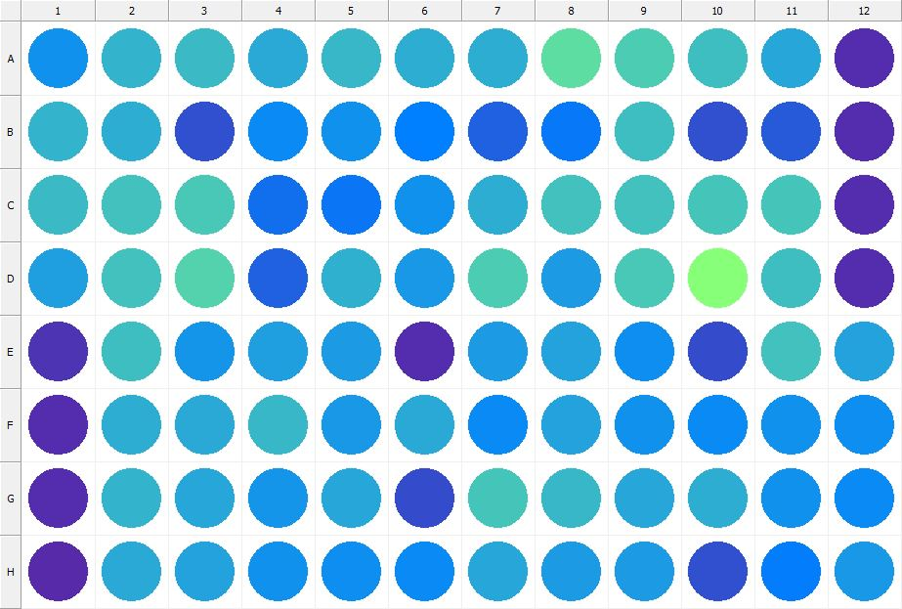

|  |
| --- |
| **Results for Tim_CTB(1) - channel 1 (RFU)** |

|  |  |  |  |  |  |  |  |  |  |  |  |  |
| --- | --- | --- | --- | --- | --- | --- | --- | --- | --- | --- | --- | --- |
|  | 01 | 02 | 03 | 04 | 05 | 06 | 07 | 08 | 09 | 10 | 11 | 12 |
| A | 97131 | 120994 | 125611 | 113746 | 122280 | 116729 | 115376 | 147798 | 135732 | 127305 | 111299 | 30411 |
| B | 119537 | 116793 | 53263 | 93782 | 97600 | 85759 | 65476 | 80896 | 126904 | 54480 | 61012 | 29331 |
| C | 124353 | 130075 | 134807 | 73775 | 79220 | 97008 | 116154 | 129113 | 129959 | 132999 | 133025 | 30303 |
| D | 106256 | 129500 | 141774 | 64685 | 119407 | 101983 | 137040 | 104249 | 134390 | 175939 | 127167 | 30351 |
| E | 34912 | 128298 | 100337 | 105981 | 103376 | 29801 | 104153 | 108342 | 94605 | 51532 | 130412 | 107897 |
| F | 30304 | 116718 | 113593 | 122981 | 103140 | 114574 | 92364 | 108264 | 97193 | 92904 | 96696 | 94178 |
| G | 30167 | 120117 | 110641 | 98631 | 111787 | 51162 | 132150 | 122339 | 110732 | 116569 | 97910 | 91975 |
| H | 28987 | 113579 | 108611 | 96811 | 95570 | 93767 | 112428 | 103346 | 104743 | 53685 | 84231 | 101245 |

|  |  |
| --- | --- |
| **Plate information** | |
|  | |
| **Plate** | 9 |
| **Repeat** | 1 |
| **Barcode** |  |
| **Measured height** | 14.78 |
| **Inside temperature at start** | 23.73 |
| **Inside temperature at end** | 23.73 |
| **Humidity at start** | 14.4 |
| **Humidity at end** | 14.4 |
| **Ambient temperature at start** | 23.83 |
| **Ambient temperature at end** | 23.93 |
| **Group** | 1 |
| **Label** | Tim_CTB(1) |
| **ScanX** | 0 |
| **ScanY** | 0 |
| **Measinfo** | De=1st Ex=Top Em=Top Wdw=N/A (14) |
| **Kinetics** | 0 |
| **Measurement date** | 11/21/2022 12:20:53 PM |
|  | |

|  |
| --- |
| **Background information** |
| Legend:  HDR1 - Plate  HDR2 - Label  HDR3 - Result  HDR4 - Signal  HDR5 - Flashes/Time  HDR6 - Meastime  HDR7 - MeasInfo |
| HDR1 HDR2 HDR3 HDR4 HDR5 HDR6 HDR7  9 Tim_CTB 0 1096 1 00:00:00.000 De=1st Ex=Top Em=Top Wdw=N/A (14) |
|  |

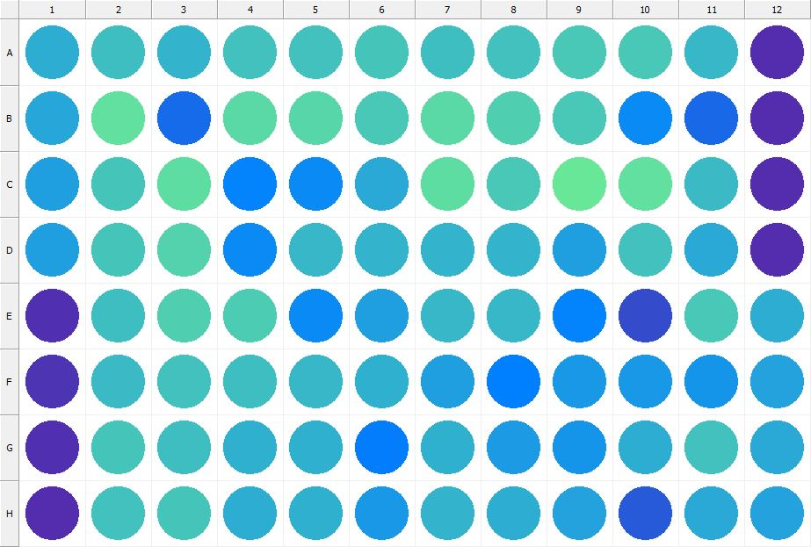

|  |
| --- |
| **Results for Tim_CTB(1) - channel 1 (RFU)** |

|  |  |  |  |  |  |  |  |  |  |  |  |  |
| --- | --- | --- | --- | --- | --- | --- | --- | --- | --- | --- | --- | --- |
|  | 01 | 02 | 03 | 04 | 05 | 06 | 07 | 08 | 09 | 10 | 11 | 12 |
| A | 115107 | 127281 | 121311 | 129959 | 130914 | 133130 | 126582 | 130945 | 133565 | 134999 | 122553 | 30550 |
| B | 110437 | 150096 | 72814 | 145102 | 142863 | 134508 | 147080 | 139182 | 134090 | 92459 | 70667 | 30509 |
| C | 107806 | 132371 | 148104 | 88288 | 91684 | 113023 | 149060 | 133496 | 155275 | 150374 | 126121 | 29981 |
| D | 107030 | 133179 | 141059 | 91972 | 123775 | 120267 | 121719 | 119942 | 107002 | 130592 | 113296 | 31188 |
| E | 32789 | 128368 | 139434 | 135875 | 93722 | 107211 | 123831 | 122782 | 88305 | 50247 | 134054 | 114964 |
| F | 33639 | 126201 | 129458 | 128506 | 123184 | 118338 | 107502 | 86285 | 101070 | 101703 | 100864 | 107921 |
| G | 32367 | 132455 | 128050 | 117400 | 119451 | 84070 | 118476 | 105244 | 100854 | 115464 | 129953 | 113459 |
| H | 29570 | 129170 | 132251 | 115405 | 118946 | 101805 | 120322 | 114828 | 110157 | 59861 | 112531 | 108559 |

|  |  |
| --- | --- |
| **Plate information** | |
|  | |
| **Plate** | 10 |
| **Repeat** | 1 |
| **Barcode** |  |
| **Measured height** | 14.78 |
| **Inside temperature at start** | 23.73 |
| **Inside temperature at end** | 23.75 |
| **Humidity at start** | 14.4 |
| **Humidity at end** | 14.4 |
| **Ambient temperature at start** | 23.93 |
| **Ambient temperature at end** | 24.05 |
| **Group** | 1 |
| **Label** | Tim_CTB(1) |
| **ScanX** | 0 |
| **ScanY** | 0 |
| **Measinfo** | De=1st Ex=Top Em=Top Wdw=N/A (14) |
| **Kinetics** | 0 |
| **Measurement date** | 11/21/2022 12:21:36 PM |
|  | |

|  |
| --- |
| **Background information** |
| Legend:  HDR1 - Plate  HDR2 - Label  HDR3 - Result  HDR4 - Signal  HDR5 - Flashes/Time  HDR6 - Meastime  HDR7 - MeasInfo |
| HDR1 HDR2 HDR3 HDR4 HDR5 HDR6 HDR7  10 Tim_CTB 0 1031 1 00:00:00.000 De=1st Ex=Top Em=Top Wdw=N/A (14) |
|  |

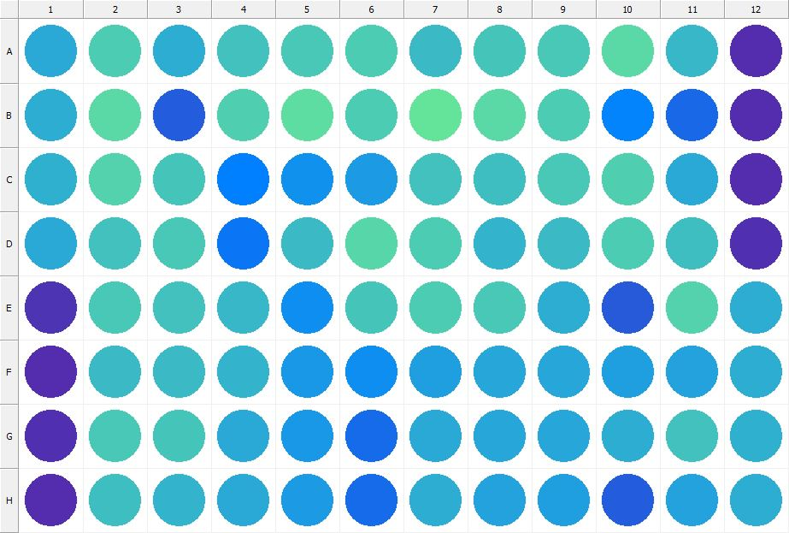

|  |
| --- |
| **Results for Tim_CTB(1) - channel 1 (RFU)** |

|  |  |  |  |  |  |  |  |  |  |  |  |  |
| --- | --- | --- | --- | --- | --- | --- | --- | --- | --- | --- | --- | --- |
|  | 01 | 02 | 03 | 04 | 05 | 06 | 07 | 08 | 09 | 10 | 11 | 12 |
| A | 113831 | 136406 | 115932 | 130612 | 135585 | 136705 | 124429 | 133145 | 134493 | 146270 | 123247 | 30994 |
| B | 116380 | 145070 | 62296 | 140071 | 147734 | 136838 | 153318 | 147105 | 136138 | 88750 | 69848 | 31110 |
| C | 117768 | 140616 | 132858 | 85496 | 97480 | 104845 | 130401 | 127685 | 134841 | 140029 | 113673 | 30857 |
| D | 112859 | 129100 | 135486 | 78335 | 125080 | 144196 | 137432 | 120888 | 124099 | 137804 | 127654 | 31338 |
| E | 34609 | 134655 | 129800 | 123914 | 95343 | 131195 | 136636 | 134862 | 116248 | 59543 | 140547 | 115583 |
| F | 30527 | 124527 | 125219 | 120216 | 102599 | 95319 | 106647 | 111548 | 110547 | 106767 | 109173 | 115636 |
| G | 32700 | 133904 | 132927 | 113975 | 101514 | 71222 | 112994 | 110560 | 111880 | 115695 | 130525 | 117777 |
| H | 29973 | 127088 | 121161 | 113716 | 103649 | 72630 | 115327 | 108974 | 106807 | 63338 | 108397 | 115658 |

|  |  |
| --- | --- |
| **Plate information** | |
|  | |
| **Plate** | 11 |
| **Repeat** | 1 |
| **Barcode** |  |
| **Measured height** | 14.78 |
| **Inside temperature at start** | 23.73 |
| **Inside temperature at end** | 23.73 |
| **Humidity at start** | 14.4 |
| **Humidity at end** | 14.4 |
| **Ambient temperature at start** | 24.03 |
| **Ambient temperature at end** | 24.03 |
| **Group** | 1 |
| **Label** | Tim_CTB(1) |
| **ScanX** | 0 |
| **ScanY** | 0 |
| **Measinfo** | De=1st Ex=Top Em=Top Wdw=N/A (14) |
| **Kinetics** | 0 |
| **Measurement date** | 11/21/2022 12:22:17 PM |
|  | |

|  |
| --- |
| **Background information** |
| Legend:  HDR1 - Plate  HDR2 - Label  HDR3 - Result  HDR4 - Signal  HDR5 - Flashes/Time  HDR6 - Meastime  HDR7 - MeasInfo |
| HDR1 HDR2 HDR3 HDR4 HDR5 HDR6 HDR7  11 Tim_CTB 0 1028 1 00:00:00.000 De=1st Ex=Top Em=Top Wdw=N/A (14) |
|  |

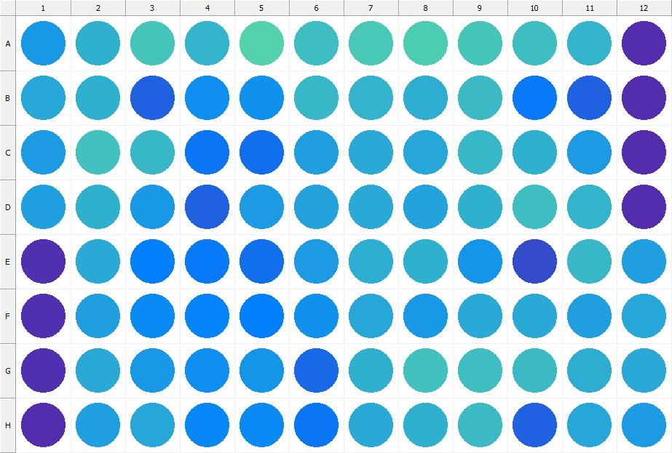

|  |
| --- |
| **Results for Tim_CTB(1) - channel 1 (RFU)** |

|  |  |  |  |  |  |  |  |  |  |  |  |  |
| --- | --- | --- | --- | --- | --- | --- | --- | --- | --- | --- | --- | --- |
|  | 01 | 02 | 03 | 04 | 05 | 06 | 07 | 08 | 09 | 10 | 11 | 12 |
| A | 102480 | 117967 | 132357 | 120764 | 140875 | 126453 | 134329 | 137676 | 132664 | 126744 | 120558 | 30558 |
| B | 111521 | 118471 | 64541 | 95362 | 98511 | 123174 | 119604 | 116492 | 126398 | 80993 | 64955 | 29833 |
| C | 104849 | 130841 | 122876 | 78125 | 74518 | 106880 | 113412 | 111698 | 122391 | 119338 | 105214 | 30355 |
| D | 106425 | 119206 | 101839 | 65050 | 103303 | 107890 | 112755 | 108887 | 117926 | 128151 | 120176 | 31063 |
| E | 33273 | 113062 | 85283 | 80460 | 73680 | 104275 | 116468 | 117981 | 99030 | 50907 | 122514 | 105557 |
| F | 32574 | 106100 | 91790 | 88600 | 86733 | 97156 | 111607 | 102221 | 112565 | 112953 | 107502 | 111915 |
| G | 32184 | 114507 | 101999 | 96073 | 99694 | 68959 | 117235 | 129700 | 127046 | 124412 | 117053 | 113151 |
| H | 30205 | 106305 | 111822 | 90993 | 92516 | 78877 | 113232 | 118929 | 125853 | 64686 | 112009 | 105318 |

|  |  |
| --- | --- |
| **Plate information** | |
|  | |
| **Plate** | 12 |
| **Repeat** | 1 |
| **Barcode** |  |
| **Measured height** | 14.78 |
| **Inside temperature at start** | 23.73 |
| **Inside temperature at end** | 23.73 |
| **Humidity at start** | 14.4 |
| **Humidity at end** | 14.3 |
| **Ambient temperature at start** | 24.03 |
| **Ambient temperature at end** | 24.03 |
| **Group** | 1 |
| **Label** | Tim_CTB(1) |
| **ScanX** | 0 |
| **ScanY** | 0 |
| **Measinfo** | De=1st Ex=Top Em=Top Wdw=N/A (14) |
| **Kinetics** | 0 |
| **Measurement date** | 11/21/2022 12:22:57 PM |
|  | |

|  |
| --- |
| **Background information** |
| Legend:  HDR1 - Plate  HDR2 - Label  HDR3 - Result  HDR4 - Signal  HDR5 - Flashes/Time  HDR6 - Meastime  HDR7 - MeasInfo |
| HDR1 HDR2 HDR3 HDR4 HDR5 HDR6 HDR7  12 Tim_CTB 0 1140 1 00:00:00.000 De=1st Ex=Top Em=Top Wdw=N/A (14) |
|  |

|  |  |
| --- | --- |
|  | |
| **Basic assay information** | |
| **Assay ID** | 24218 |
| **Assay Started** | 11/21/2022 12:14:11 PM |
| **Assay Finished** | 11/21/2022 12:23:11 PM |
| **Assay Exported** | 11/21/2022 12:27:55 PM |
| **Protocol ID** | 100568 |
| **Protocol Name** | Copy of 96well-CTB_Tim |
| **Serial#** | 1020141 |
|  | |
|  | |
|  | |
| **Protocol information** | |
| **Protocol:** | |
| **Protocol name** | Copy of 96well-CTB_Tim |
| **Number of assay repeats** | 1 |
| **Start assay repeat each** | N/A |
| **Number of plate repeats** | 1 |
| **Start plate repeat each** | N/A |
| **Is label meas. height used** | Yes |
| **Height of measurement** | Defined in label |
| **Is gripper height used** | No |
| **Mode of measurement** | By Rows, bi-directional |
| **Rotated plate** | No |
| **Soft move** | No |
| **Protocol notes** |  |
|  | |
| **Plate type:** | |
| **Name of the plate type** | 96 General |
| **Number of rows** | 8 |
| **Number of columns** | 12 |
| **Number of the wells in the plate** | 96 |
| **Height of the plate** | 14.35 mm |
|  | |
| **Coordinates of corners:** | |
| **96 General + Tim_CTB** | |
| 14.38 mm x------------------------------------------------------ x 113.38 mm  11.24 mm 11.24 mm | |
| 14.38 mm x------------------------------------------------------ x 113.38 mm  74.24 mm 74.24 mm | |
|  | |
|  | |

|  |  |
| --- | --- |
| **Platemap:** | |
| **Plate** | 1 |
| **Group** | 1 |
|  | |

|  |  |  |  |  |  |  |  |  |  |  |  |  |
| --- | --- | --- | --- | --- | --- | --- | --- | --- | --- | --- | --- | --- |
|  | **01** | **02** | **03** | **04** | **05** | **06** | **07** | **08** | **09** | **10** | **11** | **12** |
| **A** | - | - | - | - | - | - | - | - | - | - | - | - |
| **B** | - | - | - | - | - | - | - | - | - | - | - | - |
| **C** | - | - | - | - | - | - | - | - | - | - | - | - |
| **D** | - | - | - | - | - | - | - | - | - | - | - | - |
| **E** | - | - | - | - | - | - | - | - | - | - | - | - |
| **F** | - | - | - | - | - | - | - | - | - | - | - | - |
| **G** | - | - | - | - | - | - | - | - | - | - | - | - |
| **H** | - | - | - | - | - | - | - | - | - | - | - | - |

|  |  |
| --- | --- |
|  | |
| **-** | Undefined |
|  | |
|  | |

|  |  |
| --- | --- |
| **Calculations:** | |
| **No calculations.** | |
|  | |
| **Auto export parameters:** | |
| **Export format** | Plate2 |
| **Include basic assay information** | Yes |
| **Place assay information at** | End of file |
| **Include basic plate information** | Yes |
| **Place plate information at** | Beginning of plate |
| **Include protocol information** | Yes |
| **Protocol info level** | Large |
| **Include error and warning information** | Yes |
| **Include background information** | Yes |
| **Add plate number to the file name** | Yes |
| **Each plate to separate file** | No |
| **Field separator to use** | System |
| **File name format** | <DefaultDataFolder>\<Date>\<ProtocolName>_<AssayID>.csv |
|  | |
| **Operations:** | |
| Plate 1  Group 1  Measurement  Label..................................................... Tim_CTB(1) | |
| **Labels:** | |
| **Tim_CTB** | 4000137 |
| **Top mirror** | General |
| **Bottom mirror** | N/A |
| **Exc. filter** | Photometric 530 |
| **Using of excitation filter** | Top |
| **2nd exc. filter** | N/A |
| **Using of 2nd excitation filter** | Top |
| **Ems. filter** | Photometric 590 |
| **2nd ems. filter** | N/A |
| **Measurement height** | 6.5 mm |
| **Number of flashes** | 1 |
| **Number of flashes integrated** | 1 |
| **PMT gain** | 1 |
| **Excitation light** | 100% |
| **Reference excitation light** | 100% |
| **Emission light** | 100% |
| **Reference AD gain** | 4 |
| **Reference signal** | 383728 |
| **Last edited** | 2/11/2019 10:20:00 AM |
| **Last edited by** | EnVision |
| **Factory preset** | No |
|  | |
| **Filters:** | |
| **Photometric 530** | 310 |
| **Filter type** | Excitation |
| **Description** | P530 CWL=530nm BW=8nm Tmin=55% |
| **Used with** | Absorbance,DELFIA - Time-resolved Fluorescence,Fluorescence Intensity,Fluorescence Polarization,LANCE - Time-resolved Fluorescence |
| **Last edited** | 8/19/2014 4:24:21 PM |
| **Last edited by** | Installation |
| **Factory preset** | Yes |
|  | |
| **Photometric 590** | 314 |
| **Filter type** | Excitation |
| **Description** | P590 CWL=590nm BW=8nm Tmin=40% |
| **Used with** | Absorbance,DELFIA - Time-resolved Fluorescence,Fluorescence Intensity,Fluorescence Polarization,LANCE - Time-resolved FluorescenceAbsorbance,DELFIA - Time-resolved Fluorescence,Fluorescence Intensity,Fluorescence Polarization,LANCE - Time-resolved Fluorescence |
| **Last edited** | 8/19/2014 4:24:21 PM |
| **Last edited by** | Installation |
| **Factory preset** | Yes |
|  | |
| **Mirror modules:** | |
| **General** | 401 |
| **Used by** | Top |
| **Dual** | No |
| **Bias** | No |
| **Description** | BS50 |
| **Used with** | Luminescence,DELFIA - Time-resolved Fluorescence,Fluorescence Intensity,Fluorescence Polarization,LANCE - Time-resolved Fluorescence |
| **Last edited** | 8/19/2014 4:24:21 PM |
| **Last edited by** | Installation |
| **Factory preset** | Yes |
|  | |
| **Instrument:** | |
| **Serial number** | 1020141 |
| **Nickname** | EnVision |
|  | |
|  | |
|  | |
|  | |
| **Notifications:** | |
| Assay notifications:  INFO: Assay aborted at plate 12 plate repeat 1 and well H01. There may be missing results | |
| Notifications for plate 8 repeat 1:  WARNING: Plate height defined in the plate editor does not match the actual plate height. Measured height is 16.18 mm. Plate editor height is 14.35 mm. The results may be affected. | |
|  | |
|  | |

|  |
| --- |
|  |
| **Exported with EnVision Workstation version 1.13.3009.1409** |